**Methodology for construction of mechanically compacted Embankment for**

**HFM&LI Project.**

**Construction procedure of mechanically compacted Embankment:**

The procedure for construction sequences and steps to be followed in construction of compacted embankment are given as follows:

1. Embankments designated on the Drawings to be mechanically compacted shall be demarcated to the lines and grades shown on the Drawings. Initially on fixing the center line alignment of embankment with GPS by the surveyor the bed width of embankment to be measured from design drawing and dug bailing, stripping or ploughing the base of embankment and borrow pit area, removing roots and stumps of trees if any are to be done.

2. The Contractor’s operations in the excavation of material designated for use in compacted embankments or compacted backfill shall be such as will result in an acceptable gradation of soil material, as specified.

3. The specified soil when available in borrow pit or collected from elsewhere shall have to be acceptable to the JMT. Contractor is to provide grain size distribution analysis certificate (Sieve and hydrometer ASTM D-422) of soil to be supplied by him from borrow pit or carried soil from elsewhere. The soil gradation shall have to be prior approved by the JMT and the Project Manager before placing on embankment body. Further laboratory compaction test certificate (With Modified proctor test ASTM D- 1557) of the soil to be used shall have to be supplied by the Contractor at the same time.

4. The specified soil shall be stockpiled nearby the designated location of embankment and moisture content of piled soil shall be checked by the JMT and the Project Manager.

5. If the moisture content is less than desired moisture content for desired compaction (85% of MDD with modified proctor test, ASTM D-1557), the moisture shall be supplemented by sprinkling and reworking the material at the site of compaction. If the moisture content is more than required moisture content for compaction, the material shall be dried by reworking, mixing with dry materials or other approved means.

6. The material to be compacted shall be deposited in horizontal layers not more than 300 mm thick and the distribution of materials shall be such that the compacted material will be homogeneous and free from lenses, pockets, streaks or other imperfections. The excavating and placing operations shall be such that the materials when compacted will be blended sufficiently to secure the best practicable degree of compaction, impermeability and stability. The compaction operation shall preferably be spread over reaches of around 500m.

7. Each layer of material shall be compacted uniformly by use of adequate and appropriate compaction equipment (Bulldozer/ Sheep Foot RolIer / Vibratory Compactor) approved by the JMT. Compaction shall be done in a longitudinal direction along the embankment and generally begin at the outer edges and progress towards the center in such a manner that each receives equal compaction effort.

8. The compacted soil in each layer shall be tested for specified dry density of about 85% of laboratory Maximum dry density (Modified proctor test ASTM D-1557) at optimum moisture content.

9. The JMT will take samples for each layer of soil being compacted and will perform tests required to determine that the compaction is meeting the requirements of these specifications. On satisfying the compaction requirement of each layer, next layer of soil to be dumped and compaction operation to be repeated. The JMT will decide the location of the Test and collect geo reference. All the test result shall be initialed by the all members of the JMT. The test results along with geo reference shall be duly recorded in the tabular form and certified by the Convener of JMT and this shall be submitted to Project Manager with monthly quality control report. The project Director upon recommendation of the Project Manager will approve the Report.

10. The in situ dry density of the compacted fill shall be determined by the sand replacement method described in ASTM D-1556 and frequency for sampling is stated in schedule of tests for this item of work.

11. A typical cross section showing construction of embankment layer by layer is shown later in this report (Annexure-1).

12. If the material being excavated from canal or other waterlogged areas for use as embankment and material is saturated, then it shall be initially stockpiled to drain the excess water before placing it for construction of embankment.

13. Location of borrow pits from the toe of embankment are shown in the sketch (Annexure-2). Borrow pits should be kept at least 20m away from the toe of the embankment if earth is borrowed for the river side and 50 m away from the toe of the embankment if earth is borrowed from the country side and should not be made deeper than 2.5m from the ground level.

14. The contractor shall make continuous video of whole compaction work for each layer. No payment will be made for embankment construction without Video Document.

20. All instructions and specifications mentioned in the approved drawing should be followed strictly.

21. The Project Director reserves the right for the inclusion of any other points in the methodology if required for the smooth execution of works.

Annexure-1

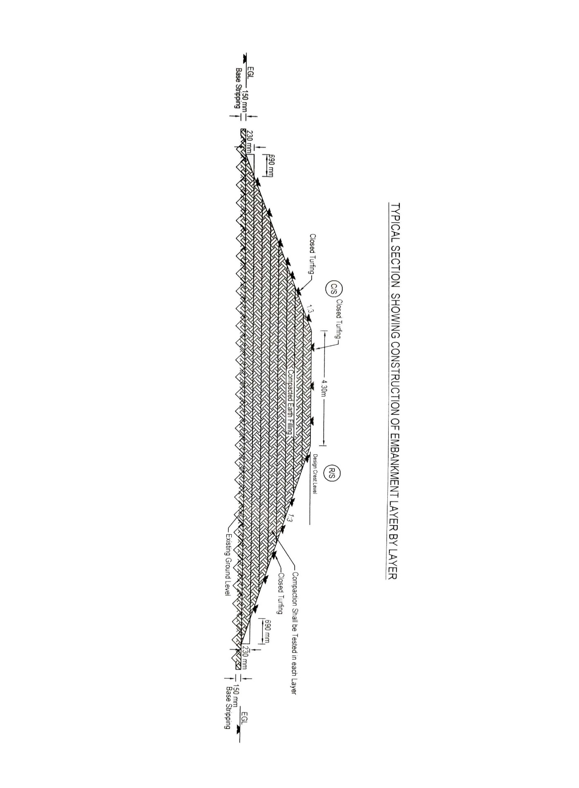

Annexure-2

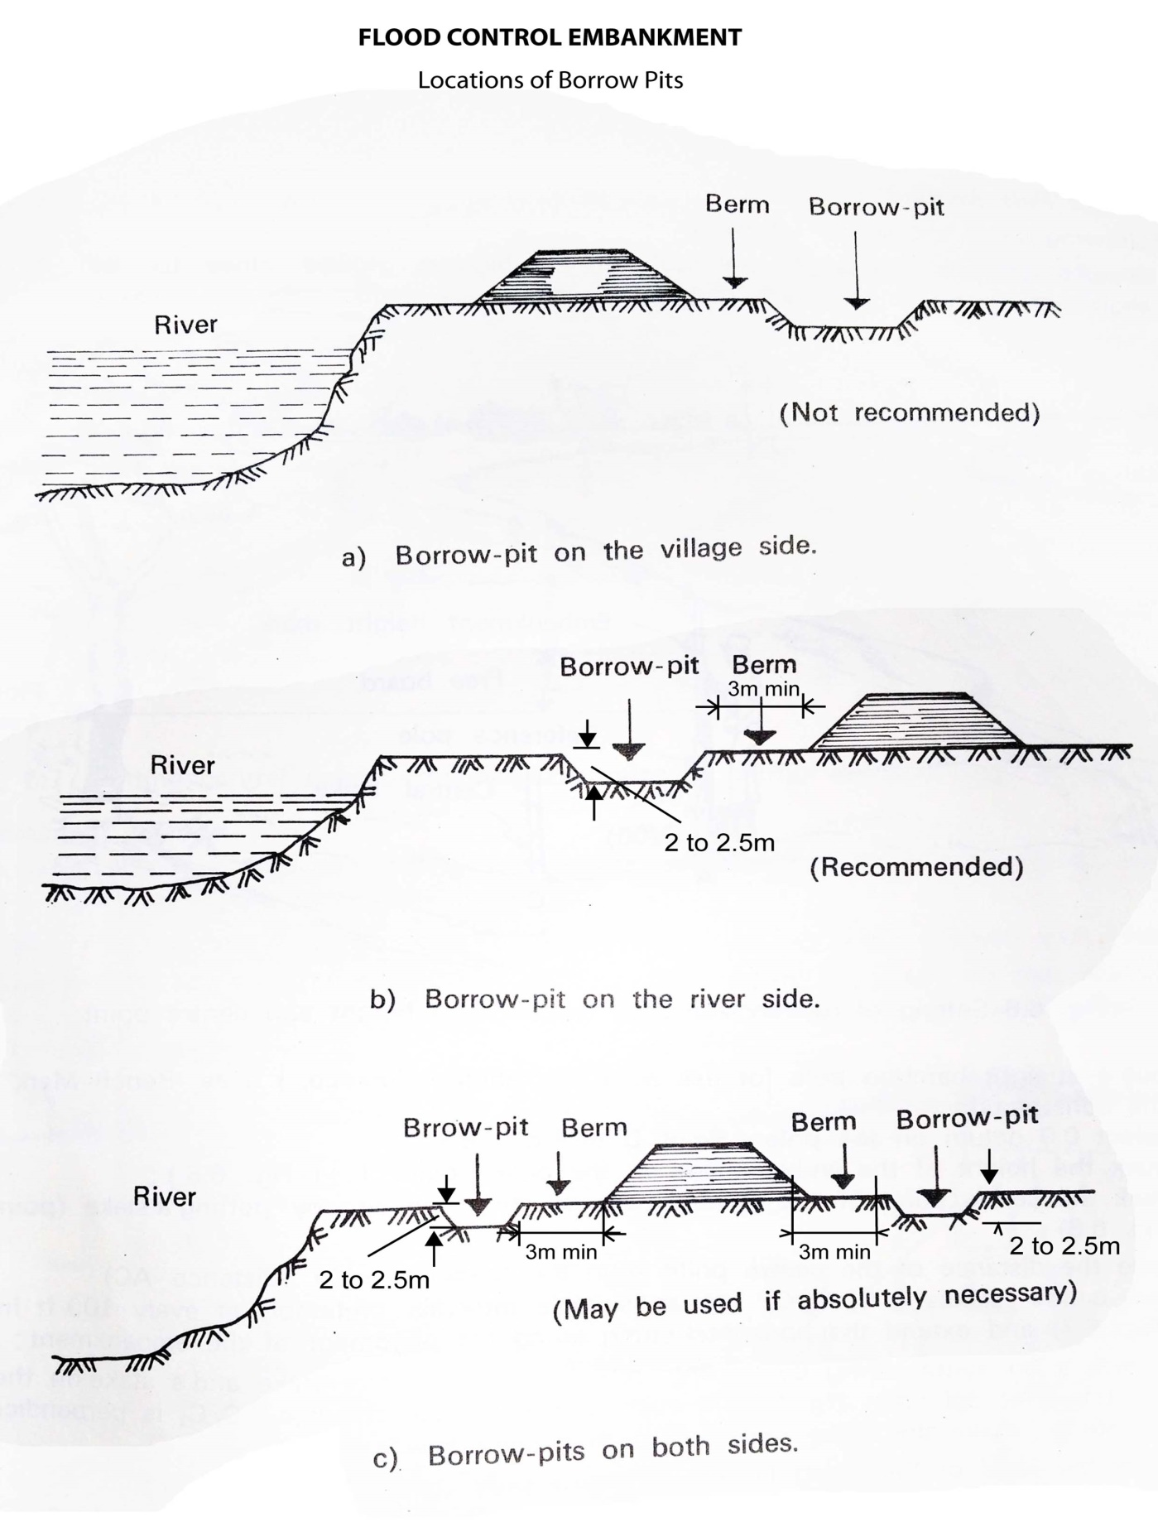

Berm

20m min

50m min

20m min